Article title
Full name of Author1* Full name of Author2**
Author1 ORCID1 ID link Author2 ORCID1 ID link
Receipt date: / /20.. Accepted date: / /20.. Publication date: / /20..
https://doi.org/10.30907/jcopolicy.vi70.848
Copyrights: © 2025 by the author.
The article is an open access article distributed under the terms and condition of the (CC By) license Creative Commons Attribution 4.0 International License

Abstract:
----------------------------------------------------------------------------------------------------------------------------------------------------------------------------------------------------------------------------------------------------------------------------------------------------------------------------------------.
Keywords:-----,------,------,------,-----,------.
عنوان البحث
الاسم الكامل للباحث1∗ الاسم الكامل للباحث2∗∗
الملخص:
-------------------------------------------------------------------------------------------------------------------------------------------------------------------------------------------------------------------------------------------
---------------------------------------------------------------------------------------------------------------------------------------------------------------------------------------------------------------------------------------------------------------------.
الكلمات المفتاحية: -----،-----،-----،-----،-----،--------.

Introduction:
----------------------------------------------------------------------------------------------------------------------.
Methodology:
---------------------------------------------------------------------------------------------------------------------.
Literature Review:
----------------------------------------------------------------------------------------------------------------------.
Theoretical and Conceptual Framework:
-----------------------------------------------------------------------.
Analytical Section Title:
-----------------------------------------------------------------------------------------------------------------------.
Results and Discussion:
-----------------------------------------------------------------------------------------------------------------------.
Conclusion:
---------------------------------------------------------------------------------------------------------------------.
Acknowledgments:
Funding Statement:
Conflict of Interest Statement:

List of References:
The reference list should be arranged in alphabetical order (A - Z)
---------------------------------------------------------------------------------------
------------------------------------------------------------------------------------------
--------------------------------------------------------------------------------.

Title:
The title should be concise and focused and should not exceed 12 words.
Abstract:
The abstract should be written in both English and Arabic and should be approximately 200–250 words. It should be presented in short, precise, and clear sentences, providing a focused presentation of the research problem, the study question or hypothesis, the objective of the study, the methodology used, and the main findings of the research, while avoiding unnecessary detail.
Keywords:
Keywords are listed directly after the abstract. They should accurately reflect the research topic and should consist of four to six keywords. They should be written in both Arabic and English.
Introduction:
This section presents an analytical introduction that begins with the general background of the study topic and explains the significance of the research from both theoretical and practical perspectives. It also provides a brief contextual overview of the relevant literature in preparation for identifying the research problem and research gap. The section then clearly presents the research problem, formulates the main research question and hypothesis, and concludes with a brief overview of the study's structure.
Methodology:
This section presents the study's methodological framework in detail. It explains the adopted methodology and the reasons for its selection, presents the analytical tools used, whether qualitative, quantitative, or both, describes the nature and sources of the data, and clarifies the study’s limitations. The presentation should be precise and coherent, allowing the reader to understand how the research was conducted.
Literature Review:
This section presents previous studies in a comparative and analytical manner, organized by specific trends or approaches, highlighting points of agreement and disagreement, identifying the strengths and limitations of each approach, and ultimately clarifying the research gap that the current study seeks to address.

A Suggested Format for Writing Literature Review: The literature has interpreted the phenomenon through multiple approaches. Some studies have addressed the structural dimension related to the nature of the state, while others have focused on the role of political elites. However, these approaches have overlooked the interaction between…
Theoretical and Conceptual Framework: This section defines key concepts related to the research topic, presents relevant theories, identifies the researcher's analytical perspective, and explains the relationship between the theoretical framework and the study's subject.
Note: The literature review may be integrated into the Theoretical and Conceptual Framework section in studies that require an integrated analytical structure, provided that this is done through a critical analytical approach that highlights the contribution of the literature to shaping the conceptual framework of the study, while maintaining the clarity of the research gap and avoiding purely descriptive narration.
Analytical Section Title: This section should be divided into logically interconnected main and sub-sections. It should follow a systematic, coherent sequence in presenting ideas, emphasizing analysis over mere description and relying on evidence and data to construct scientific arguments.
Results and Discussion: The first part of this section presents the researcher's findings objectively and directly. The second part discusses these findings by interpreting them, linking them to the theoretical framework, and explaining their implications and significance. The discussion should be presented in a systematic, progressive manner while avoiding excessive citations.
Note: In some types of research, the analytical content may be integrated within the Results and Discussion sections, so that the presentation is limited to these two sections. In this case, the Results section presents the data, indicators, and analyses derived from the study, while the Discussion section is devoted to interpreting these results, linking them to the theoretical framework, comparing them with previous literature, and explaining their implications and significance. This does not eliminate the need to present previous studies analytically in a separate section or within the theoretical framework, depending on the nature of the research, as stated in the note related to Section II: Theoretical and Conceptual Framework.
Conclusion:
The conclusion should provide a concise summary of the main findings of the research, demonstrating the extent to which the hypothesis has been confirmed and presenting the general conclusions, without repeating in detail the content discussed in the main text.

Acknowledgments:
Funding statement:
Conflict of interest statement:

List of References:
The reference list should be prepared according to the Chicago Author-Date 16th edition style, with entries arranged alphabetically, consistent formatting, and URLs or DOIs included where available.
The phrase “(in Arabic)” should be added at the end of each Arabic source translated into English. For guidelines on reference formatting in our journal, please visit the following link:
https://jcopolicy.uobaghdad.edu.iq/index.php/jcopolicy/libraryFiles/downloadPublic/21Technical Formatting of the Manuscript: Manuscripts should be formatted using the Simplified Arabic font for Arabic text and the Times New Roman font for English text, both in size 14, with line spacing of 1.15-1.5, 2.5 cm margins, and bold, numbered headings. The manuscript should not exceed 8,000 words. For more information on publication guidelines and requirements, please visit the following link: https://jcopolicy.uobaghdad.edu.iq/index.php/jcopolicy/Guidelines_for_Authors

Tables and Figures: Tables and figures should be inserted within the text in their appropriate locations, numbered sequentially, and referred to in the main text. The title of the table should be written above the table, while the source should be indicated below it. The figure title and source should be written directly below the figure.

Sample Table:
Table No. (1): Distribution of government spending on social sectors in
Iraq (2020–2024)
Sector | 2020 | 2021 | 2022 | 2023 | 2024
Education | 8% | 8.5% | 9% | 9.2% | 9.5%
Health | 5% | 5.3% | 5.7% | 6% | 6.4%
Social Welfare | 12% | 12.5% | 13% | 13.2% | 13.5%
Source: (Iraqi Ministry of Finance 2024; World Bank 2025).

Sample Figure:
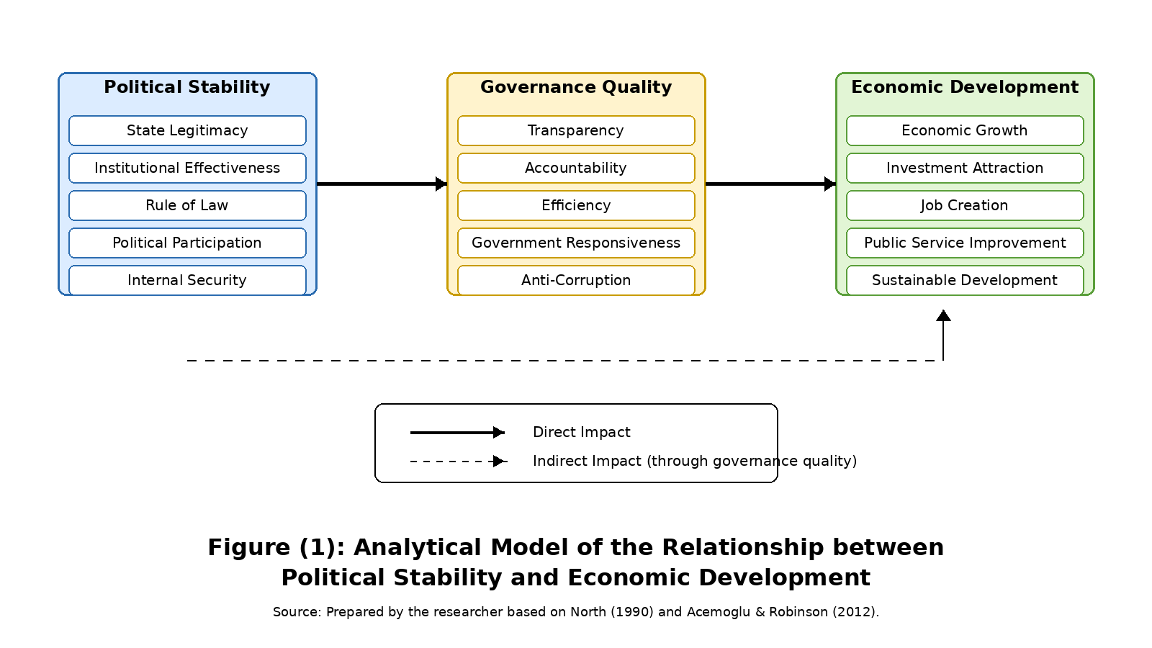

* Author1 Academic degree/ State/ University/ Department/ Specialization. Academic email/ Mobile:.
** Author2 Academic degree/ State/ University/ Department/ Specialization. Academic email/ Mobile:. Corresponding author: ……..; email: …..@......
∗ اللقب العلمي الأكاديمي للباحث1/ الدولة/ الجامعة/ القسم/ الاختصاص الدقيق.
∗∗ اللقب العلمي الأكاديمي للباحث2/ الدولة/ الجامعة/ القسم/ الاختصاص الدقيق.

